**HOMEWORK 1**

**Problem 1.**

Write an HTML page like the image below (use headings, **<div>**, paragraphs and **<ul>**) :

* 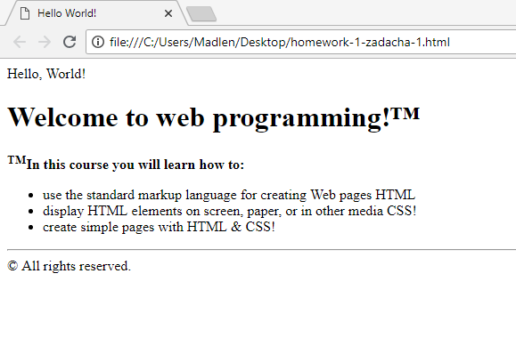Use the TM Symbol Trademark - **&trade;**

**Problem 2.**

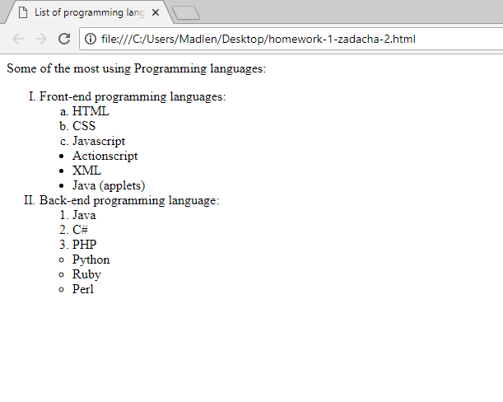Create a HTML page that holds **nested lists** like the example on the below (without the border and the rounded corners). Use **<ol>**, **<ul>** and **<li>**.

**Problem 3.**

Create a Web Page like the following.

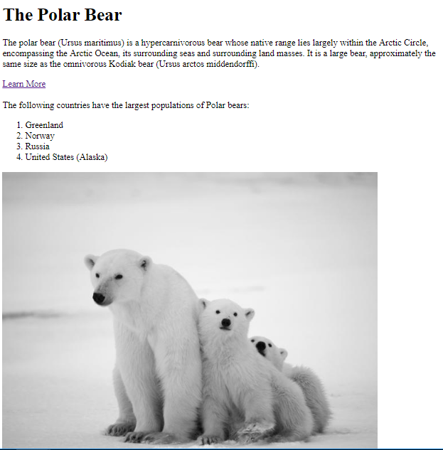

* Title: **The Polar Bear**
  + <h1> for heading
* Hyperlink: <https://en.wikipedia.org/wiki/Polar_bear#Population_and_distribution>
* Text: **use paragraph**
* List: **use ordered list and unordered list**
* Image: **your choice**